Table of Contents
1. Exigence
2. Purpose
3. Audience
4. Genre
5. Stance
6. Design
7. Course Learning Outcome #1
8. Course Learning Outcome #2
9. Course Learning Outcome #3
10. Course Learning Outcome #4
11. Course Learning Outcome #5
12. Course Learning Outcome #6
13. Course Learning Outcome #7
14. Course Learning Outcome #8

Self Assessment-How I’ve Developed
Introduction Paragraph
I. explain what I’ll be writing about
A. How I’ve developed in rhetorical situation
B. How I met the course learning outcomes
Exigence
I. Definition
II. Give example as to how my exigence has changed
Purpose
I. Definition
II. Give example as to how my purpose changed
Audience
I. Definition
II. Give example as to how my audience changed
Genre
I. Definition
II. Give example as to how my genre changed
Stance
I. Definition
II. Give example as to how my stance changed
Design
- Definition
- II. Give example as to how my design changed
Course Learning Outcome #1
I. In class exercise on Trump
II. Practice exercise on applying to Apple
III. Martin Luther King Jr. classwork
Course Learning Outcome #2
I. Read stuff with a purpose, not stuff that isn’t relevant
II. Peer assessment/self assessment
III. Martin Luther King Jr. classwork
Course Learning Outcome #3
- Must know audience
- Course Learning Outcome #4
I. Peer review workshops
II. Pre post packet
Course Learning Outcome #5
- powerpoint

- Course Learning Outcome #6
I. Avoid .com sites II. Google author III. Evaluate for bias
Course Learning Outcome #7
I. Essays
Course Learning Outcome #8
I. MLA works cited page

Self Assessment-How I’ve Developed
Throughout this course, I have learned many things, including all of the rhetorical situations and what they mean, and the course learning outcomes. In the beginning of this semester, I had no idea what the rhetorical situations were, and it took some time to comprehend them. When I first learned about them, the one that gave me the most trouble was exigence. That’s because I couldn’t distinguish it from purpose. Now though, I can clearly tell the difference between the two. As far as the course learning outcomes are concerned, I didn’t focus as much on these. However, looking at them a few weeks ago, I saw that I achieved growth with those as well. Some of them I had never done before or knew about, such as locating research sources. I learned that using .com sites aren’t usually the best for accurate information. Also, by taking a class in the library by a librarian, I learned how to use City College’s online database, where I can find scholarly articles, and many other peer reviewed papers. It can be said that by taking this course, I learned and improved upon the rhetorical situations and the course learning outcomes.
The first rhetorical situation I learned about, and at first the most confusing, is exigence. Exigence is the problem or situation that causes someone to speak out, whether it is by a speech, essay, or some other form. As seen from my very first reflection paper which was my literacy
narrative, it didn’t cover any rhetorical situation. “Before writing this paper, I thought that it was going to be a drag. However, as I started to write, I found that I could not stop myself from writing. I’m glad that you, my teacher, required me to write this paper. This is because I was able to write about my writing past and the ups and downs I’ve had with it. I believe that I did quite well in writing this paper because it was enjoyable to write. I liked how it didn’t have to be written like a formal essay where one would be answering an essay question. With this paper, I hope to have you, my teacher, understand me, my writing ability, and the style in which I write. I want you to see that I’ve struggled with writing in the past, and that I hope that you can help me to understand how to write even better moving forward. So, I hope this paper helps you understand me, therefore you’ll be able to help me on future assignments.” However, upon continued writing and practice, my reflection papers improved. I did incorporate them into my next two reflection papers. From my expository essay, my exigence was stated by “the exigence for me writing this paper is that I love Siberian huskies, and have always loved sled dogs.” And finally, the exigence from my argumentative essay was stated by “the exigence for me writing this paper is because of what happened with Jackie Robinson.” I went from not having an understanding of exigence to being able to complete the task.
Next, I will show how my purpose has changed and improved over the duration of this class. But first, one must know what purpose is. Purpose is what the writer is trying to do with his or her work. An example could be to inform. Now, in the beginning I always got confused between purpose and exigence. In my first assignment, as seen in the previous paragraph, I didn’t mention the purpose. However, in my second major assignment, the expository essay, I stated that “the purpose for me writing this paper was to show the reader hard facts that proved Siberian huskies are the best sled dogs to run the Iditarod, and to inform the reader about
Siberian huskies and the Iditarod.” And in my argumentative essay, the purpose was “to show people how sports have influenced social change in the United States.”
Audience is who the paper is intended for. For my audience, it is seen in my first assignment that my audience is unclear. However, as we get to my expository essay, my audience is people who “will most likely be someone who is interested in running the Iditarod and wants to know what type of dogs he or she should get. Also, someone who is just interested in learning about the topic may want to read my paper.” When I wrote my argumentative paper, since it was on a different topic, my audience was people who “could be athletes, historians, or people interested in the topic.” I believe that the audiences I chose were appropriate for the corresponding essays.
The next rhetorical situation is genre. Genre is what the assignment is. For my first assignment, the genre was a literacy narrative. The next genre was an expository essay, while the third was an argumentative essay.
Next, the rhetorical situation, stance, will be covered. Stance is the position of the writer in relation to the audience and topic. My stance in the literacy narrative is slight; basically it was that I was glad to have written the assignment. However, I didn’t address this clearly. In my second assignment, the expository essay, my stance is “that the dog should be able to handle cold weather, since its taking place at the end of winter in Alaska. Also, the dog should like to run, because that is what it’ll be doing for over one thousand miles.” While this is better, it still doesn’t relate to my audience much. In my last assignment, my stance is “that sports have indeed brought a positive social change.” Again, this relates more to my topic and less to my audience. Still, there was improvement from my very first attempt at this.
The last rhetorical situation is design. Design is the way a piece of work is presented. For all of my assignments, the design was consistent. My design for each piece of work was print.
For the first leaning outcome, I will evaluate my growth on analyzing, in writing and reading, a variety of genres and rhetorical situations. I have done this by in class work. The first example is when I did and exercise on audience. The assignment was to pick either Kanye West or Donald Trump, and then evaluate which one would become either a better or worse president. I had to do this by writing to a best friend, a blog post, and to my instructor. This was a great exercise on audience because seeing the difference in how people write depending on who their audience is made me understand it much better. Another in class exercise that helped me analyze rhetorical situations was writing a pretend cover letter to apply to Apple. In the cover letter, we had to explain all of the rhetorical situations for writing the letter. This helped me get an idea for the rhetorical situations because afterwards, we discussed as a class a few people’s examples, and tweaked them so they were correct. By doing this, I was able to better understand them better. Lastly, we had also read Martin Luther King Jr’s “Letter from Birmingham Jail” in which I was able to read a different type of paper, and saw how Mr. King used all of the rhetorical situations in his letter.
For the second course learning outcome, I will discuss my strategies for reading, drafting, and revising. When I read through information, I try to look for specific information, not material that doesn’t help me. For example, if I am reading something that is many pages long, I will skim through the stuff that doesn’t pertain to my topic. However, if I am reading something extensive and it’s necessary to be able to remember most of it, I will summarize in a small
paragraph what I read from either a paragraph or a page.
A way that I do draft work is by peer assessment and self assessment. A strategy I use for revising is once I am returned my peer reviewed sheets, I will take into consideration what was said, and from there I will revise my paper. If I don’t receive any comments, then I will still read over my paper at least once more and fix any mistakes or awkward phrasing.
For the third course learning outcome, I learned to recognize and practice key rhetorical terms when engaged in writing. When I write a paper, whether it be a literacy narrative, expository essay, or an argumentative essay, I usually always write with an intended audience in mind. This is because if I know who my audience is, then I can present my material more accurately. However, the majority of the time I do not know my intended audience, so I write to an anonymous audience. So, when I write, I elaborate on topics that aren’t human knowledge.
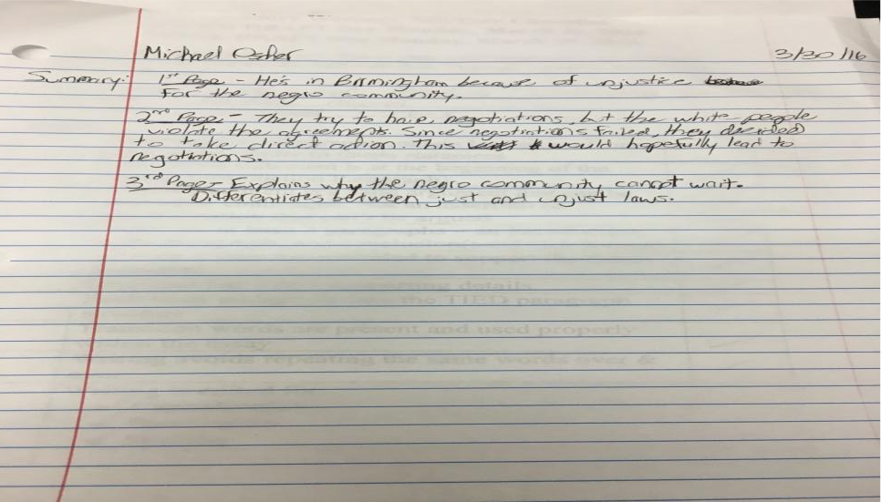
An example of this can be seen from my expository essay’s intoduction, in which I elaborate on the Iditarod. “The Iditarod is a race that takes place solely in Alaska, starting in the capital, Anchorage, and finishing in Nome. The first modern day Iditarod race took place in 1973, however the first proclaimed Iditarod was in 1967 and only covered twenty five miles, compared to the modern day race of roughly one thousand one hundred miles. The Iditarod is a race that honors the mushers from the late nineteenth and early twentieth century’s.” Since I wasn’t certain of who my audience was going to be, I decided to write to an anonymous audience, and so I had to explain what the Iditarod is.
Next, for the fourth course learning outcome, I will discuss how I have engaged in the collaborative and social aspects of the writing process. One way in which I did this was by participating in peer review workshops. For these, I got into a group with three other people and we all read everyone’s papers. Then, we filled out a paper that required us to check off boxes if the person fulfilled the certain requirement, and then on the back we wrote down comments.
Another way I was engaged in the writing process was by completing a pre post packet. A pre post packet has me fill out certain material which helps me greatly when trying to write the final
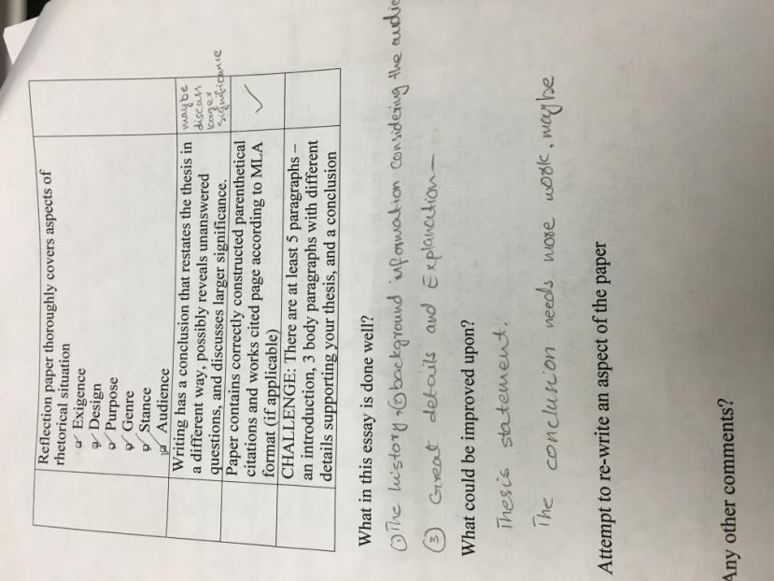
draft. What would you like to know? How many people compete each year? Do they all use Siberian huskies? How do the dogs train when there’s no snow?
Do you have a thesis in mind? When it comes to running the Iditarod, the dog breed the Siberian husky can be said to have no competition when it comes to being the best sled dog.
Research- keywords, articles, books, journals, “dot coms.” What are you looking for? (charts, arguments, maps, surveys, reports, etc?) Scholarly sources, past stats, reliable websites, books.
Is it reliable? Yes
How can you tell? Where did you find it? What did you find? (title and author, web addresses, etc. List here) I found it on the CCNY library page, and the database section. Also, they’re published books.
The fifth course learning outcome required me to use digital technology to address a range of audiences. I was able to do this by making a PowerPoint presentation. Usually, when I write an essay, only my teacher reads it. However, with this PowerPoint, I was able to address my whole class. This was much different than writing an essay because I had to physically be there and present it. With an essay, I just submit it and that’s it. With the PowerPoint presentation, I had to gather the courage to stand in front of my class and speak to them about my topic. Here part of my PowerPoint outline is shown.
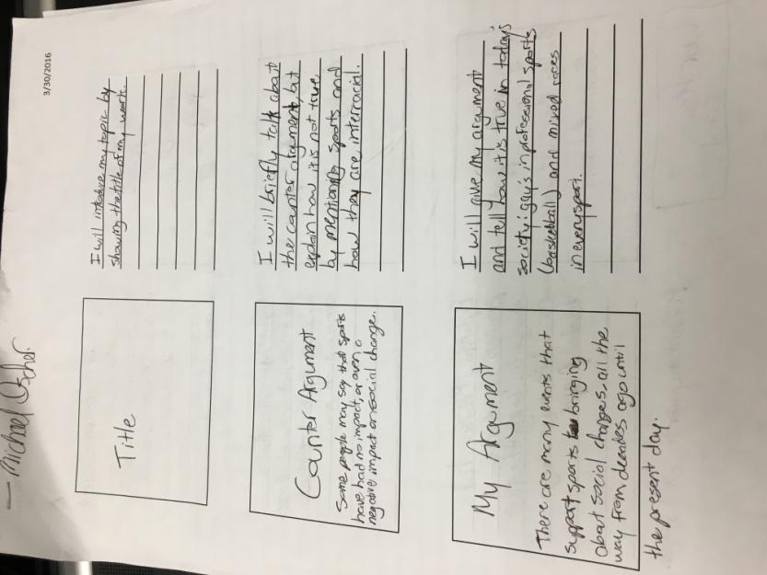
For the sixth course learning outcome, I will evaluate how I learned to locate research sources in the library’s databases and on the internet, as well as evaluating them for credibility, accuracy, and bias. The first thing I learned when starting my research was to avoid .com sites. This is because they often don’t have accurate information, and the person or people who contributed to the site may not be qualified or credible. A good way to see if the author or authors are credible is to Google his/her name, or their names. If they appear, and they have other work published, then it is safe to say that they are a fine source to cite. The opposite is also applied too. If you Google their name and nothing appears, then most likely they are not a credible and accurate source. In order to find information on the school’s library database, I spent one class learning from a librarian how to locate exactly what we needed. This applies to what was previously stated. Lastly, I was also taught to search for bias, which means a one sided argument. For example, if I read an article on how basketball is beneficial to your health, and it was written by a professional basketball player, it is most likely biased.
The seventh course learning outcome is to compose texts in which I integrate my stance using strategies such as summary and argumentation. For example, my stance on how I viewed English is easily seen through a small summary from pages 3-4 of my literacy narrative which says, “I had a choice of what English class to take in ninth grade, honors or regents. Of course, I decided to take honors, as that is the class all of my friends were going to take. Also, I didn’t think it would be much of a challenge. Boy was I wrong. In all of high school, I had never done so poorly in class. We started out the year by writing these papers called “critical lens” papers. I never understood how to write one, and my grade showed that. I don’t recall ever getting above a 70 on a critical lens essay. At this point in my writing career, I was so unmotivated to do well in my English class, because no matter what I did, I couldn’t do well. Well, that didn’t change.
Instead, it only got worse. Second quarter of ninth grade we read Romeo and Juliet. First of all, I found that play, and still find that play, incredibly lousy. On top of that, we had to write an essay on it. Since I’m much more of a math kind of person, I’ll put my situation like this: Dislike for writing + boring play = terrible assignment. Next up we read Great Expectations. Yay. We had to do a research paper on it, and I did my research. I wrote what I thought was not a half bad research paper. I guess my teacher didn’t find it very good, since when I got it back it had a 33 written on it. At this point, I hated writing. It didn’t matter if it was one paragraph, one essay, one research paper. I couldn’t stand the thought of writing a single thing. Now were in the fourth and final quarter of ninth grade. I’m almost done with this dreadful course. Maybe we won’t have a major writing assignment this quarter. Wrong. We had to write a 5 page historical fiction research paper. Ok, at first I wanted to just drop out, but as I started researching and writing, I found it kind of enjoyable. For the first time in a long time, I was able to write something using my imagination. Now yes, I had to be historically correct, but I was able to make my own story. To this day I’m proud of the story I wrote. Once again though, my views on writing were crushed. I received a 76. I worked so hard, was proud of it, and all I got was a 76. I hated writing.” My stance on my topic in my expository essay can also be seen by arguing my point. “So, when it comes to running the Iditarod, the dog breed the Siberian husky can be said to have no competition when it comes to being the best sled dog.”
The last course learning outcome had me practice systematic application of citation conventions. I was able to do this by properly citing my sources whenever I used them whether it is in my expository essay or my argumentative essay.
So, it is seen that over the course of this class, I have received a thorough understanding of the rhetorical situations, along with the course learning outcomes. While I may not have
grasped the concepts at first, in the end I have. I now see that when I write, I must think of many things, such as the rhetorical situations. These help a writer such as me because then I get to clarify information that I have written. They also allow me to think of what I have just written, and if it needs to be revised or not. In all, I have learned much from my time in this class, and hope to take with me in future classes what I have learned.

