Riding on the Wings of Words: My Self-Assessment Over the past semester, I have written many papers for my English Composition class. Letters, essays, reflections, all designed to further finesse my writing skills. Many nights were
spent tapping away on my computer, proofreading and editing to make sure my papers, even drafts, were the best I could hand in. My background in writing was a good start when I started this course; I used to write some stage plays in my performing arts days. Also, returning to college as a mature age student allowed me to use my vast life experience and the ability to link my ideas in a creative flow. However, I had a lot to improve on and my time in English 11000 gave me the tools to do so. There are several Course Learning Outcomes with which I should have met, and I believe I have met all of them by the end of my course.
As a team, my classmates and I started to explore and analyze a variety of genres. We explored works by great writers and speakers, such as Maya Angelou and Martin Luther King for inspiration; we even looked at examples of other past students’ essays as guidance to follow for our own writing assignments. After we received our first assignment back, however, our teacher broke the bad news, “I don't think many of you understand the rhetorical situation.” So we had a go at practicing the rhetorical situation together as a class, using a hypothetical proposition: writing a 300 word cover letter, selling myself as a prospective worker to the Apple Store. We worked together to discover our purpose, exigence, genre, stance, audience, etc in writing this
letter. We worked together to dig deep under the layers and found hidden meanings in our writing and reflecting on our intention to write.
Personally, for my first attempt in writing my reflection page, I wasn't sure if I was writing it correctly at all. Exploring the rhetorical situation for a hypothetical task as a team broke the ice for both the classroom and for my writing. It changed my perspective in looking at why I wrote about something in a certain way. After that, every reflection of mine became stronger, as can be seen in my reasoning in my Literacy Narrative vs my Expository Essay. In my Literacy Narrative reflection, I state who my audience is with no explanation behind it:
However, in my Expository Reflection, I am able to explain in more depth who my
audience are and how I tailored my writing to suit them: My teacher commented on this “Nice work here”. I have grown as a writer to discover
hidden meaning and purpose in my work through my rhetorical situation. I can now practice and recognize key rhetorical terms and strategies when I'm tasked with a writing situation.
In the actual Literacy Narrative itself, we were to examine how our own personal literacy history helped shape the writer we were today. I wrote about a stage play experience and working with an older actress, Sharlene, who was a veteran writer and performer herself. In my first draft, my teacher said I should expand more about my experience with her and how she
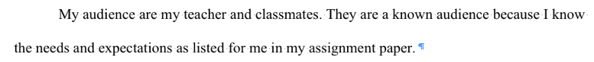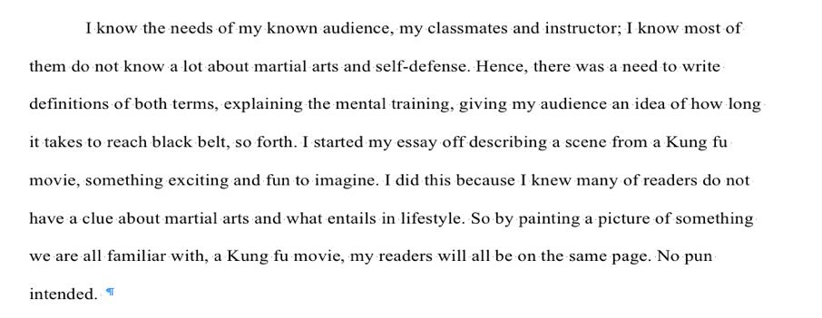
helped shape me as a writer, and ultimately, as a better person. This example is from my first draft:
And here is from Page 3 of my revised Literacy Narrative:
My teacher this was a “great improvement from the first draft” and that it connected to me more.
With my background in writing stage plays, I've always veered towards creative writing. Upon returning to college as a full-fledged adult, I was awakened with a jolt, as though college splashed a bucket of cold water on my face. I had to write what now? MLA what? Citations?! I had to get back to into a different writing mode to achieve my Course Learning Outcomes and
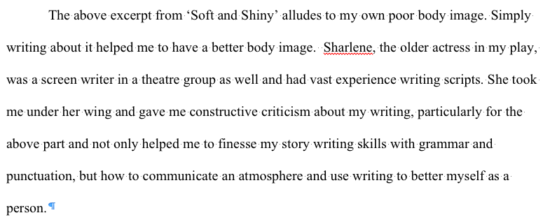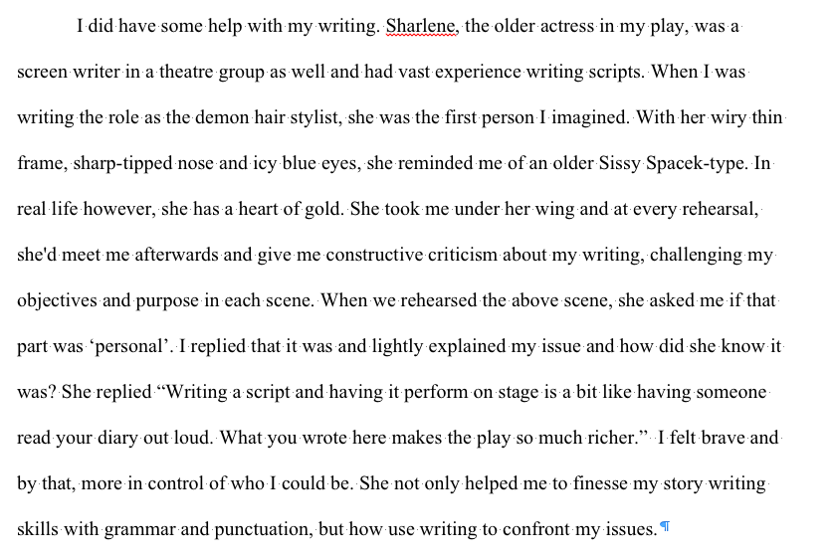
pass the course. Thus, new strategies for reading, drafting, collaborating, revising and editing had to be developed. One tip I learnt from the Norton Field Guide to Writing textbook was that when drafting, write the whole essay in one go. Write all your ideas down and don't stop writing until you have a complete first draft. This was the best strategy I've used for drafting my essays because it forced me to brainstorm and play with different ideas to write about. When stuck on writing my thesis, I would write down exactly what I was thinking and rework the words on the page. The perfectionist in me always made sure that my draft was pretty much the final product – I wouldn't stop working on it until it was pretty much a final coherent piece.
However, I was having a problem with my punctuation and format layout. For example, this is from Page 2 of my Literacy Narrative, where I had incorrect usage of single quotes and no italics for titles:
And from Page 2 of my Expository Essay, showing incorrect punctuation for in-text citations:
My punctuation was consistently incorrect. I was gung ho that I would make less mistakes in my future papers. I started using my previous essays with my teacher’s corrections as a guide to “what not to do.” Upon finishing my drafts, I would have my previous papers
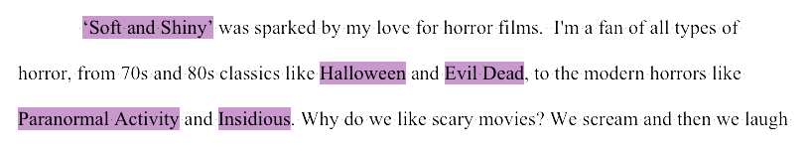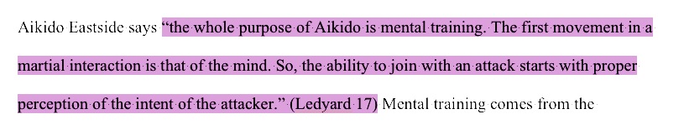
physically in front of me and I would check back and forth to see I wouldn't make the same mistake twice. You can see a difference in my Argumentative Essay overall:
This strategy has helped me tremendously. I also discovered the use of a formal outline, especially for my larger Argumentative Essay. Being such a long paper, I had to organize my points first. My formal outline meant I had a firm structure in writing and knew how to flow my essay easily. Even during my drafting process for this Self-Assessment, I wrote out points for each learning outcome as an informal outline and linked the points together for a smooth writing process. For example, see the last attached handwritten draft notes page. Like setting the foundation of a house before I built it with bricks, I laid the groundwork down to ensure I would write my self-assessment to the best of my ability.
Personally, developing reading strategies was a challenging task because it required the most focus and attention to detail. We didn't simply read our own essays; we had to practice reading other classmates’ essays as well. We conducted peer review workshops to work on each other's drafts. I still need to work on my reading strategies because I often need to read a paper twice, first to find relevance in texts and then second to proofread and we didn't have that much time in our class workshops. I'd say my best strategy was reading the first sentence, the topic sentence; something else I had to learn about in this course! I’d check that the paragraph relates to topic sentence. It was an interesting collaborative aspect to show my draft to a classmate. At first, I believed it to be a waste of time to have my writing judged by someone who wasn't the teacher. But I realize it's the opposite; they saw things I could never see in my writing. By letting them into my personal space, I felt vulnerable, yet, inspired to try new things and see how they
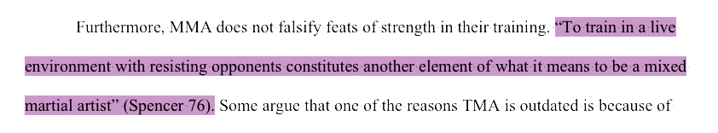
reacted to it. I worked with different classmates in every workshop and every time we collaborated, I found out something I could improve on in my writing.
Furthermore, I received a lot of positive feedback from my classmates about writing. See the attached peer review sheet filled out by _________ (Page 14) about my Expository Essay. You'll notice Mr. ________ comment on the bottom of his peer review saying he enjoyed my essay about my topic, martial arts, would perhaps try learning self-defense in his free time. My purpose was to educate my audience on martial arts and its benefits – looks like my mission was complete, at least for one reader! By collaborating with them and listening to their feedback, this told me I was on the right track and I was engaging with my subject matter.
Similarly, along with my classmates, other people in the martial arts community inspired me. As such, I used anecdotes in both my Expository Essay and Argumentative Essay. He is an example from my Argumentative Essay:
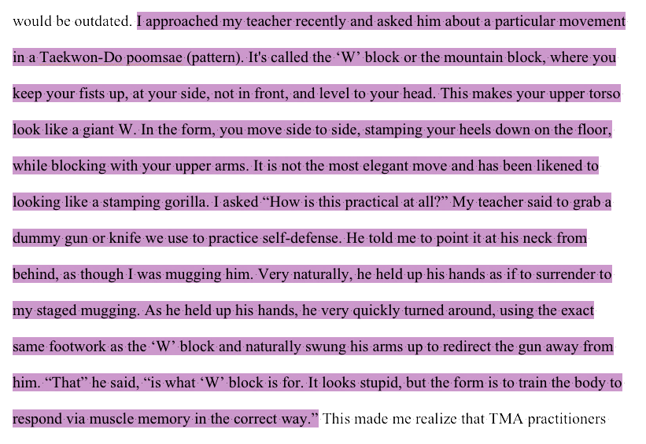
The subjects of my anecdotes, Sam and my Taekwon-Do teacher, Master Kwok, both had interesting things to say to me about my topic, martial arts. Neither of them knew I was writing an essay at the time, but what they had to say was so meaningful to me, I had to use it in my paper. Anecdotes make a nice personal touch in an otherwise long and technical essay; my ears always perk up at the introduction of a personal story. As I continue writing for college, I shall let others inspire me and let a “lightbulb” go off.
Collaborating with teachers significantly helped my writing process. During the semester, one of our classes included a workshop in the library with Mr. Hoffman and he taught us how to use the library databases to locate academics journal articles for research. Immediately after, I found sources for my Annotated Bibliography and used the research material for my Expository and Argumentative Essays. In class, I learned to look for certain criteria in my research material. It's so much more than Googling, and click! Research material has to have expert opinions and not be too outdated. There shouldn't be a biased opinion either; if there is evidence of a counter argument, it's probably a reliable source. Upon learning this, I decided not to use a particular source from my Annotated Bibliography in my research because it was from the 1970s; far too outdated for my research. A lot of articles about martial arts in general are pretty biased, so I mostly stuck to expert opinions who have years of martial arts experience to influence my writing about my chosen topic.
Another Course Learning Outcomes was to understand print and digital technologies and use them to address a range of audiences. Naturally, our PowerPoint assignment where we presented our argument in front of the class, was the assignment to satisfy this outcome. I had steadily written many papers and wrote knowingly for my teacher, but the pressure was on when I had to present in front of my whole class with a digital medium. Presenting orally is vastly
different to writing! You use your whole body to tell your message and cannot just read off a page; you must engage and interact with your audience. Being a former performer, public speaking comes naturally to me. I had fun presenting and by using PowerPoint, I was able to share my love and knowledge of martial arts and make my argument to my classmates. Mr. Wong’s comment in his peer review was an exigence that created a new purpose – I hoped my audience would want to try martial arts for themselves, like Mr. ______. To make it engaging, I used a volunteer to demonstrate one of my key points, so as to physically show my point, not just verbally. That's something I could never do with my essay! My stance with my argument had always been informed and assertive, but presenting my oral argument gave a different tone; it was much more light-hearted and humorous, in an effort to be engaging.
However, I still made a mistake on my PowerPoint presentation. I missed indentations in my Works Cited page. As the semester went on, our attention to detail for correct citations was crucial. While it seemed nit-picky, this was so important for our college careers – if I was sloppy with my citations, they would only get sloppier. Developing good habits for writing would set me up for success. After every essay, a separate Works Cited page was required, citing every source we quoted or paraphrased in our essay. In-text citations were imperative to give due credit to our courses and to avoid accidental plagiarism. As a class, we were given examples of in-text citation from other past students’ papers. We pointed out correct and incorrect citations to test our citation skills and practice systematic applications of citation conventions.
Finally, for the Argumentative Essay, I was expected to draw my argument from the Expository Essay and from sources listed in my Annotated Bibliography. I already made an argument about the relevance of martial arts in a modern world. I had to take it one step further and synthesize the research to create my counter argument about martial arts being outdated and
impractical. It was unusual for me to write the opposite of my view, because it wasn't easy to write an argument for something I didn't believe in. It required a lot of unbiased approach, open mind and proper synthesis of my research material. This was a great exercise for my writing skills.
As a result, there has been a tremendous change in my writing skills this semester. Recently, in my other class, World Humanities, my professor said my writing is excellent and has become so sophisticated. I credit English 11000 for letting me bloom as a writer. I firmly believe I have achieved all Course Learning Outcomes through all my research, assignments and class work. I'm excited to continue using the writing skills I've learned in this course and applying them in my future college papers. I’m ready to excel and go far with my college career.
