Content
Self-assessment essay on course learning outcome Comments and feedbacks from fellows and the professor on the literacy narrative essay ...... 4, 5
Literacy narrative essay reflection piece ......................................6
Example on note taking strategy .................................................7
Expository essay thesis statement ..................................................9
Argumentative essay thesis statement .........................................10
Notes and comments from the professor on the Argumentative essay ................................10

My Journey of Learning to Write in English
In this self-assessment you will see the drastic change in my writing style as well as the accomplishment of learning the course outcomes of English 11000, as I take you through the journey of my learning how to write in English. You will notice this change in the different examples from my work that I will provide later through this assessment. As a new Afghan- immigrant, and English being my second language, I had a hard time writing essays for this class. However, through different techniques presented by the professor and the book: Norton Field Guide to Writing (NFG), I started becoming more proficient in writing and constructing my papers. Not only this course played a pivotal role in improving my writing skills, but has also been proved to be a major source of useful knowledge through beneficial class activities, assignments, and workshops.
In this course, I got to choose a topic of my own interest as a theme to write about. I chose to write about the hijab and Muslim women. Firstly, and most importantly as a Muslim girl who wears a hijab, I thought of this course as to be a proper platform where I can clear up some negative stereotypes regarding Islam and Muslim women. Secondly, I wanted to add to my own knowledge of the hijab and Islam itself. Thirdly, and lastly, I wanted to learn about the different opinions about the hijab among Muslims themselves which was also the thesis for my argumentative essay.
There was a strong emphasis on learning the rhetorical situations: audience, purpose, exigence, design, medium and different genres, throughout the course period. Recognizing the audience in our writing is what I believe the most crucial part of all rhetorical situations. Clarity and descriptive writing helps the audiences, especially the unknown ones, understand the topic even more, no matter how common and universal the topic is. There was an in-class exercise where we had to write three different letters to three different audiences: a friend, the professor, and an online blog, about Kanye West vs. Donald Trump on presidency. Everyone’s letters varied from one to another as our audiences changed in the three letters. The exercise helped me to have a better understanding of the audiences’ expectations.
When writing my literacy narrative essay I tried to make the essay as descriptive and fun
as possible, for the audience. I learned this technique from the NFG which emphasized on more
descriptive and vivid details for the literacy narrative essay. Looking at my workshop fellows’
and the professor’s comments, I can tell that I have accomplished what I had attempted for. Here
are the comments and notes I received from my colleagues and the professor on my literacy narrative essay:
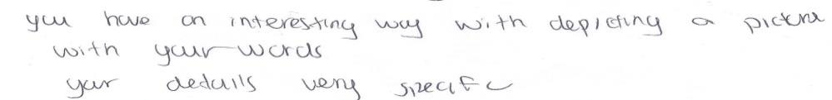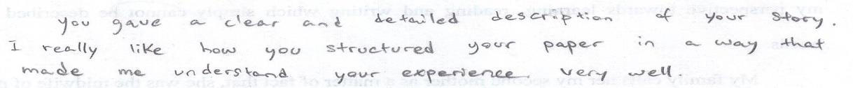
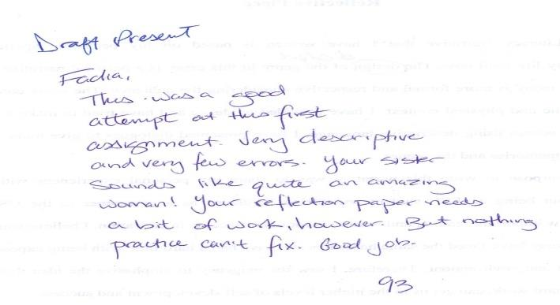
Thus, it clearly depicts that descriptive writing makes the paper fun for the reader.
Another and equally important rhetorical situation to consider while writing a paper is the purpose of the topic we are writing about. I believe I had a strong purpose and a reasonable exigence for writing about the hijab. However, the exigency and purpose; in fact, all other rhetorical situations for my literacy narrative essay’s reflection did not meet the professor’s expectations, as it can be seen in the comments I received from my professor in the evidence above. Not only me, but I believe all my fellow classmates were, to some extent, unclear about the new terms being used in the class. Following is a shot of my literacy narrative essay reflection paper where I failed to illustrate the rhetorical terms properly:
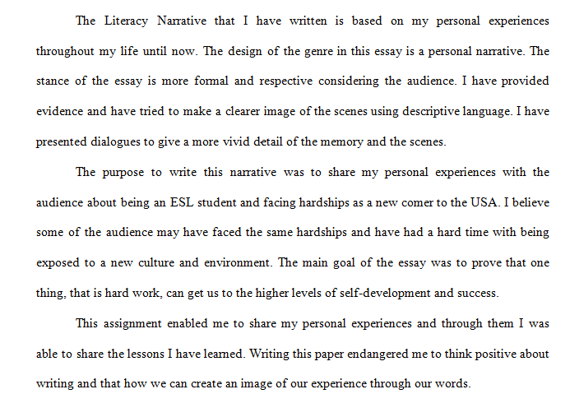
However, after practicing the rhetorical terms in another in-class exercise: writing a reflection on a cover letter in which we tried to sell ourselves to the Apple store, the class got to know more about the rhetorical situations. I also got a comment, “That’s deep!” from the professor, when I read the exigency out loud for this particular exercise. I continued to write well-constructed reflection papers; all my fellows, including myself, were clearer about the rhetorical terms after this exercise.
Moreover, throughout the course period, I have been engaged in research, reading, and note taking which also had a great impact on my critical thinking as well as on my reading skills. One technique that I always used was to look for the points and evidence in the text that supported my argument, and disregarding other information. For instance, when doing research for my expository essay, I used my last semester’s Sociology book and tried to find all the evidence regarding Islam, the hijab, and women in other religions as well. Obviously I did not use all the information, but it would give me a general idea of what I will be doing for the essay.
The following scanned paper is an example of my note taking strategy; the stars are used as a reminder for the points that were more significant and relevant to the argument.
Furthermore, in a workshop session held by Professor Carr with Mr. Hoffman, we got to learn additional helpful techniques for searching books, scholarly articles and resources regarding our topics. Mr. Hoffman, a librarian at the City College of New York, also provided his email address where we could discuss with him about the resources we were looking for. When constructing my annotated bibliography essay, I failed to find a book which represented the hijab positively. I contacted Mr. Hoffman who then helped me to find an acceptable book and
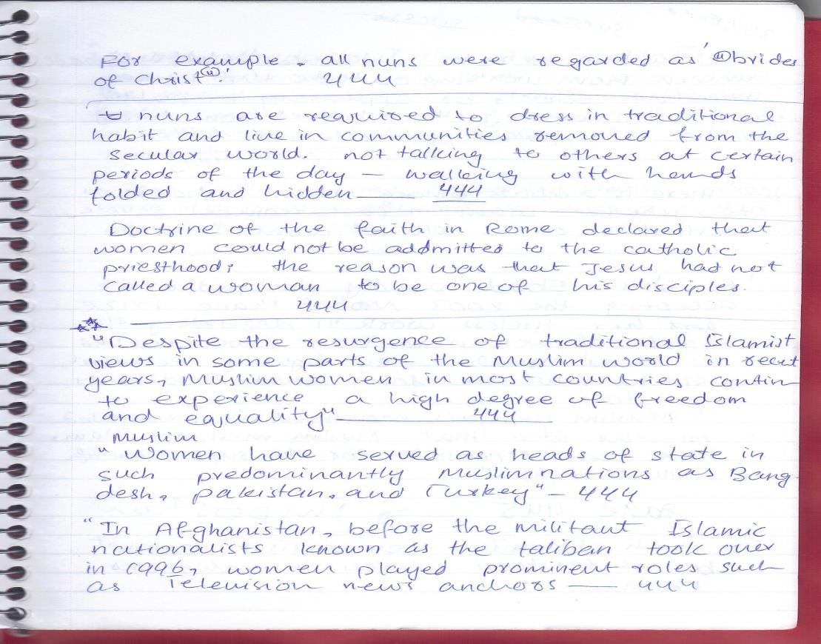
other credible resources as well. This workshop not only helped me in locating credible and accurate resources inside the school library database, but also proved useful in finding resources online and in public libraries as well.
This was not the only time I had a discussion with someone regarding my assignments. Throughout the past semester, I have been engaged in many advantageous discussions and friendly arguments with my friends, family members, and the professor as well, around my topic. Engaging in meaningful and productive discussions with others was one of the fun outcomes of this course. Since my topic was about the hijab, I would ask for my Muslim friends’ opinions regarding the hijab. The two groups’, those who wear the hijab and those who do not, beliefs fell into two different categories which built an intense curiosity inside me. I also sought my niece’s help, who goes to an Islamic studies school; she then had a discussion with one of her teachers as well. My niece showed me one of the verses from The Quran, which later proved to be a strong point to support the idea that women; in fact, no one in Islam is forced to do anything against their will. This argument can be seen in the sixth page of my argumentative essay, where I have supported the idea that women in Islam are not forced to wear the hijab.
Similarly, I would ask some of my fellows to read my essays and give a reasonable criticism, so that I can improve on my essay. I also went to the Writing center of the college, but sometimes even after receiving criticism, I would feel lost and could not figure out how to reconstruct my essay. Not knowing the language and its complicated grammar would always add to my stress and anxiety, but the hard-worker I am, I always tried to find ways to overcome every obstacle. I kept seeking help from my fellows, friends and the professor and I cannot emphasize enough how much it proved useful in organizing and constructing my papers.
I spent days and nights, composing texts: summarizing, interpreting, and analyzing the sources for my expository essay. At the workshop for the expository essay, my fellows gave me some useful feedbacks on my grammar issues; however, they liked the overall content of the essay. The tutor at the Writing center as well, gave me a sense that there is no need for changing anything for the final draft. I was pretty excited to see that ‘A’ grade on my paper; however, it turned out to be a ‘B’. “But why?” well, here comes the struggles with constructing the thesis statement. The content of the essay did not support the thesis and therefore the paper definitely deserved a ‘B’ grade. It is crucial to be sure of the correlation between the thesis statement and the content of the essay we write. Keeping this in mind, I aimed not to commit the same mistake for my argumentative essay and as a result my grade improved as well.
Here is the thesis I wrote for my expository essay:
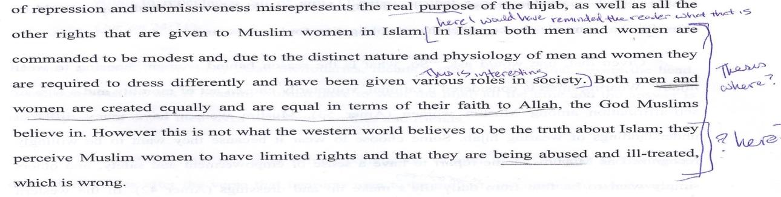
Looking at the notes, it can be seen that the professor was not clear about the thesis statement and the following pages did not support the thesis as well.
My argumentative essay thesis:
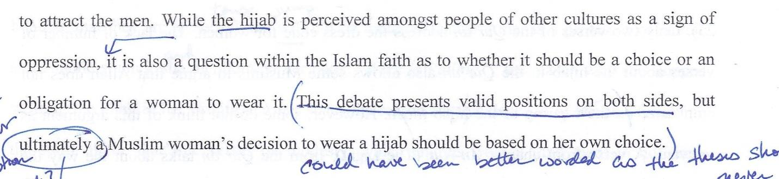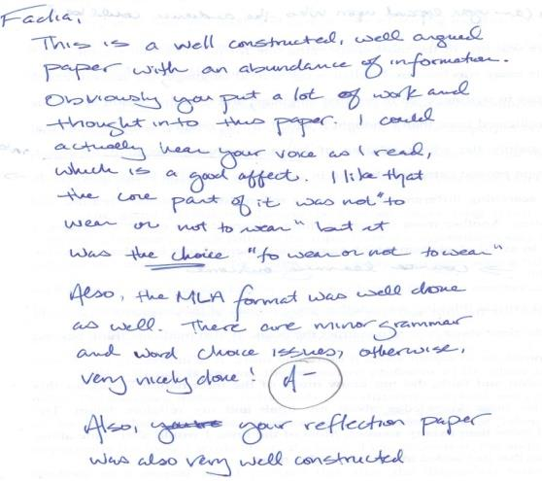
In this shot of my argumentative essay, you can see notes and suggestions from the professor for the thesis statement; however, overall grade shows that this time I had improved in constructing the thesis statement and the paper as well.
Also, I had to take care of the MLA format now, which was quite unfamiliar for me at first. Citing everything we wrote from other sources helped us prevent plagiarism which is an essential step towards becoming a fine and honest writer. Not only this helped us to avoid piracy, but also trained us to be more creative, and to dig deeper into our own thoughts and feelings.
In addition, this course also helped me become a better speaker through a PowerPoint presentation assignment. Not only the medium changed in this task, but so did the range of my audience. I was not only speaking to my professor; now I had to present what I had complied together to all my fellow classmates. We had to combine the information from both the expository and the argumentative essay. I spent hours, organizing my PowerPoint slides and practicing in front of the mirror, which was fun. However, it was challenging considering the less time we were given to present our topics. Overall, the assignment added to my knowledge and the criticism I received will always be in my mind when doing future presentations for other classes.
As a result, English 11000 has helped me overcome all the low self-esteem and fear I had because of not knowing how to write in English. Before, I would ask my niece to help me write an essay or even a post on social media, but not anymore. In fact, I have noticed that I am the one helping her in constructing her papers for her school assignments. I have learned immeasurable amount of knowledge and skills from this course. I feel more confident than before while writing an essay, an application, or a speech which gives me a great sense of joy. However, I still have a long way ahead in improving my writing skills, but the journey has become much easier now with the skills I have earned from English 11000.

