Criteria | Exceeds (9-10 points) | Meets (7-8 points) | Nearly Meets (5-6 points) | Does Not Meet > 4 points | Your Score
Uses a range of writing  strategies | Skillfully selects and uses a range  of writing strategies such as comparing and contrasting, using concrete details, description, personal experience, and EVIDENCE  OR  Masterfully uses a more limited range of writing strategies. | Accurately selects and uses a  range of writing strategies such  as comparing and contrasting,  using concrete details,  description, personal experience, and EVIDENCE  OR  Accurately and effectively uses  a more limited range of writing strategies | Attempts to use a range of  writing strategies such as  comparing and contrasting,  using concrete details,  description, personal experience and EVIDENCE  OR  Ineffectively uses a limited range of writing strategies. | Writing strategies are used ineffectively. Does not apply strategies such as comparing and contrasting, using concrete details, or description. Lacks personal experience and evidence.
Creates an organizing  Structure (TIED Paragraph structure) | Writing is clear, concise, and well organized with excellent sentence/paragraph construction. Thoughts are expressed in a coherent and logical manner. | Writing is mostly clear, concise, and well organized with good sentence/paragraph construction. Thoughts are expressed in a coherent and logical manner. | Writing is unclear and/or disorganized. Thoughts are not expressed in a logical manner. | Writing is unclear and disorganized. Thoughts ramble and make little sense.
Demonstrates  understanding of  English language  conventions | Demonstrates consistent control of grammar, usage, punctuation, sentence construction, and spelling. Very few errors found. | Demonstrates control of usage,  grammar, punctuation, sentence  construction, and spelling.  Occasional errors found. | Demonstrates some control of usage, grammar, punctuation,  sentence construction, and spelling. Frequent errors found. | Demonstrates little control  of usage, grammar,  punctuation, sentence  construction, and spelling.  Numerous errors found.

Additional 8-10 points awarded for 5-8 creditable sources; proper MLA format = ____/10
TOTAL = _____/50x2 = _______/100

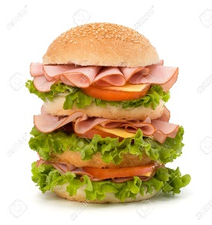

COMMENTS:

